News Content Fragment

Page Reference -<https://www.ancestry.com/corporate/newsroom/in-the-news>

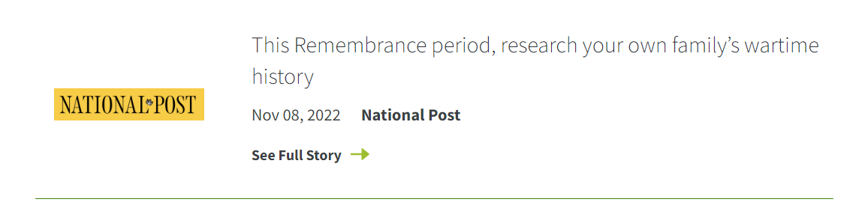

To author the news, we are using the below path to create a content fragment.

<https://author-ancestry-dev2.adobecqms.net/assets.html/content/dam/ancestry-corp/News-Content-Fragments>

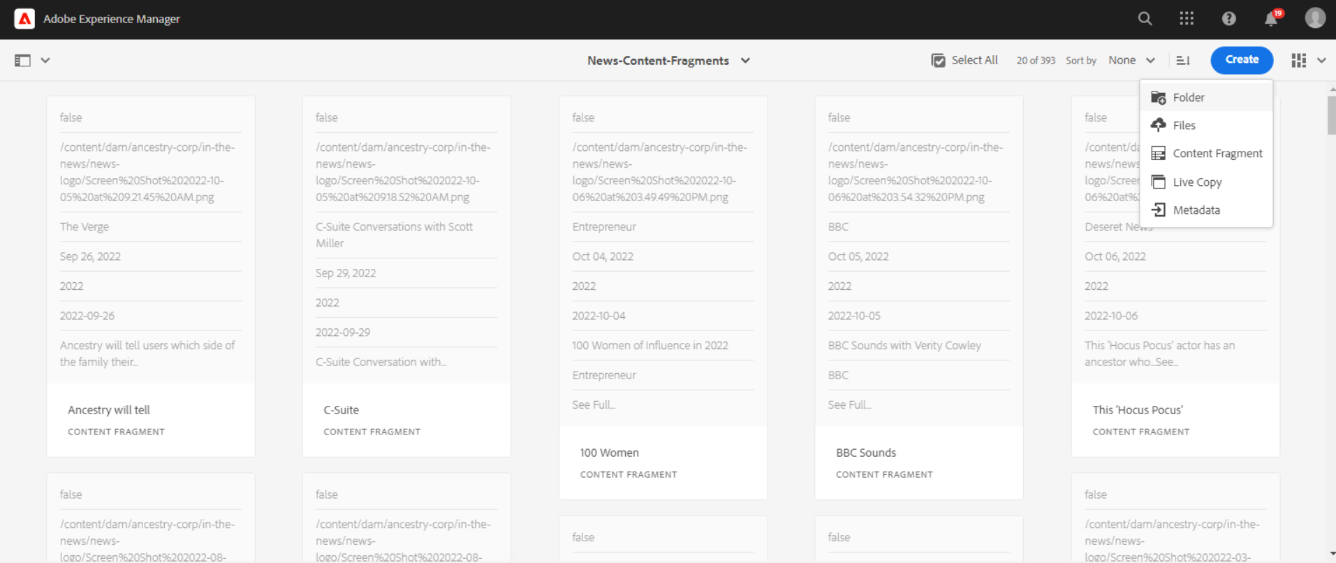

Click on Create Button, and select Content Fragment.

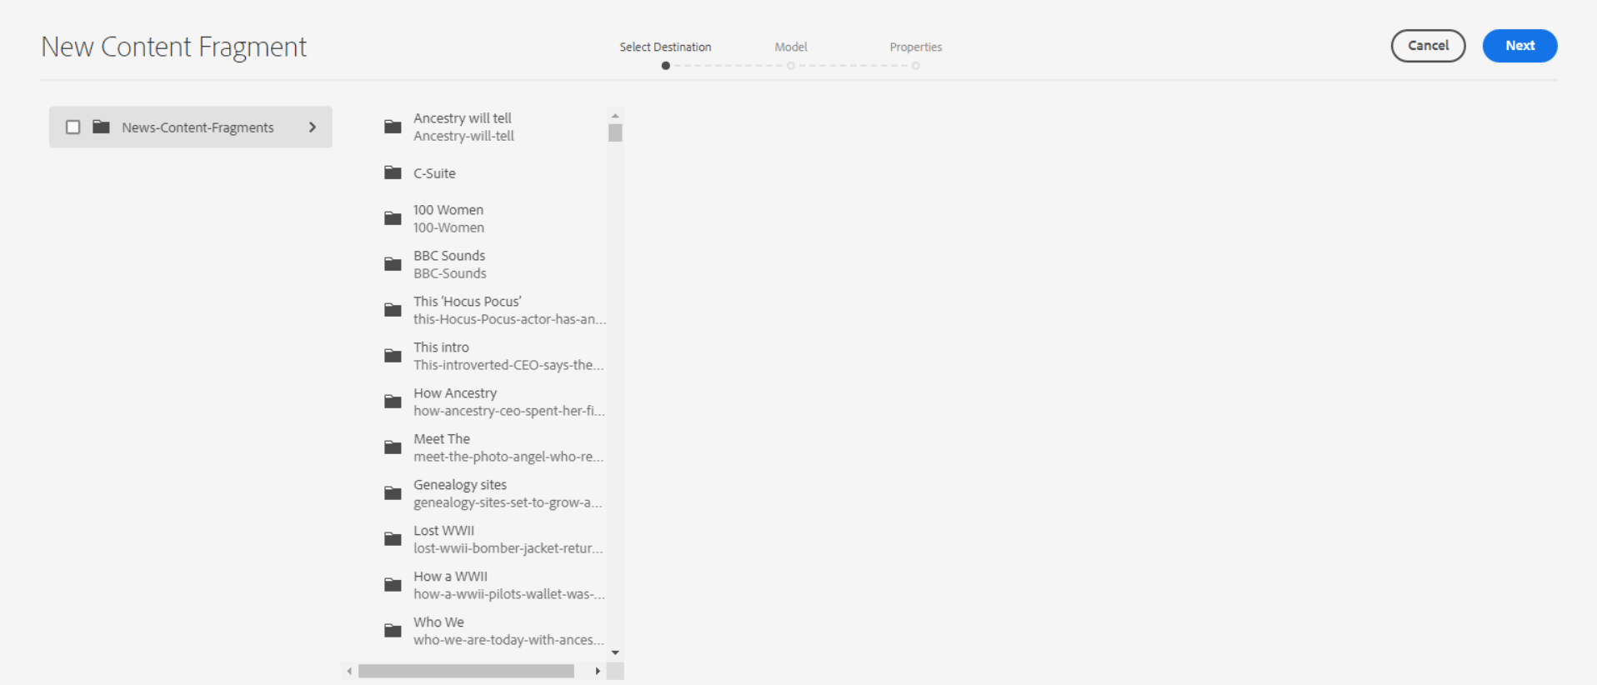

Then above window will be open, Select News-content-Fragments Modal

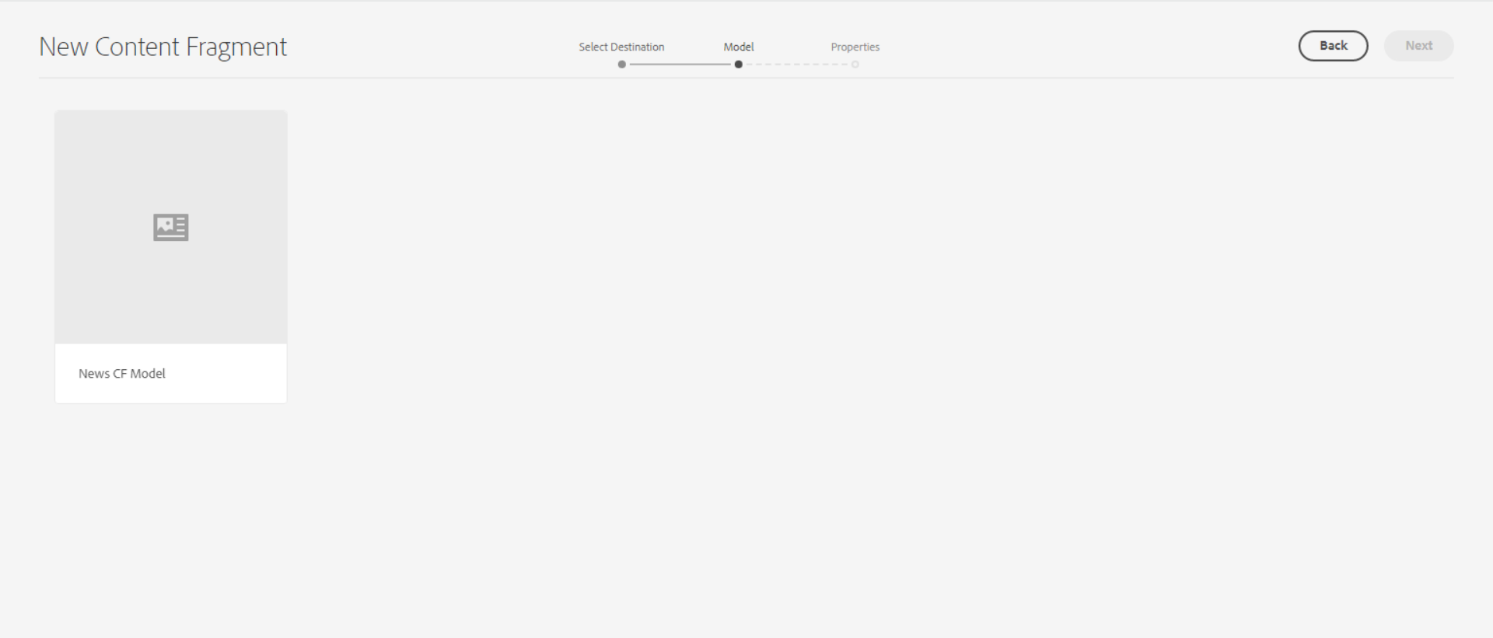

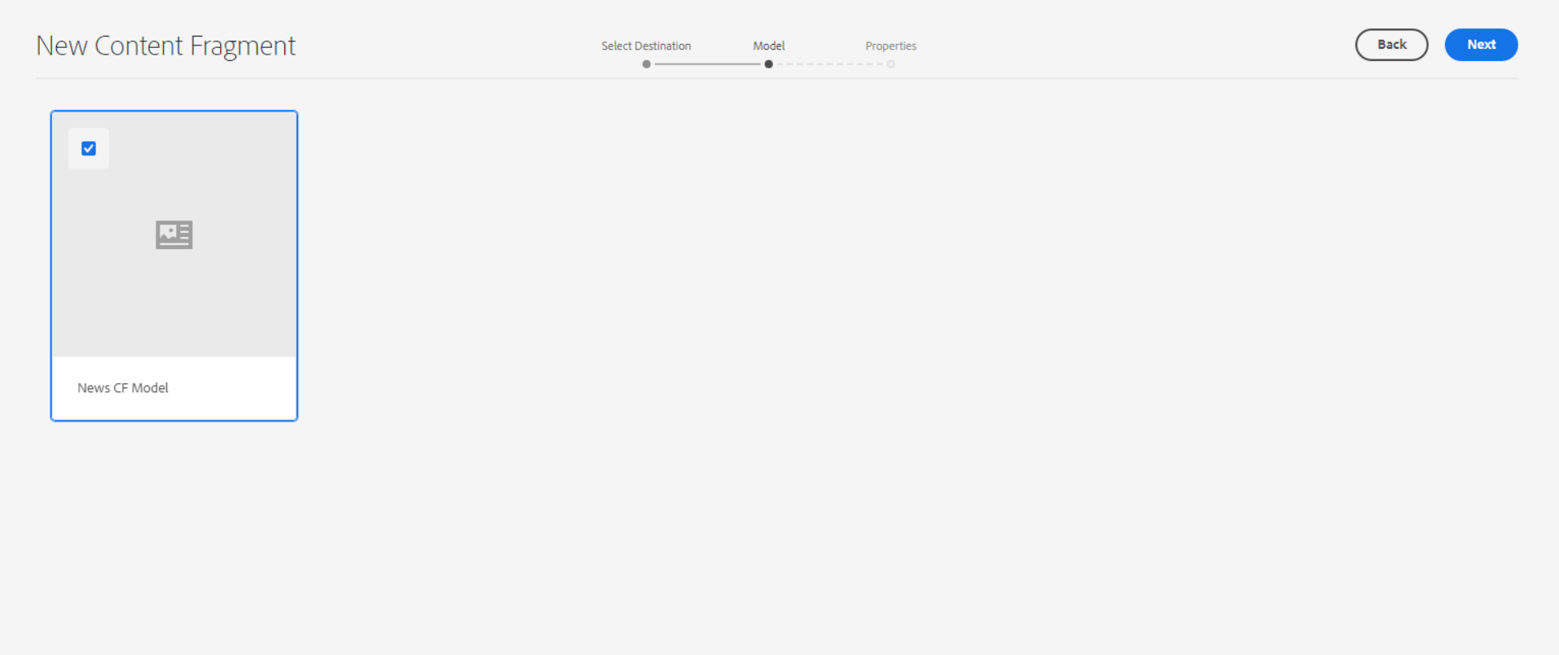

Then above window will be open, Select News CF Model box, click on Next Button, then properties window will be open.

Basic Tab

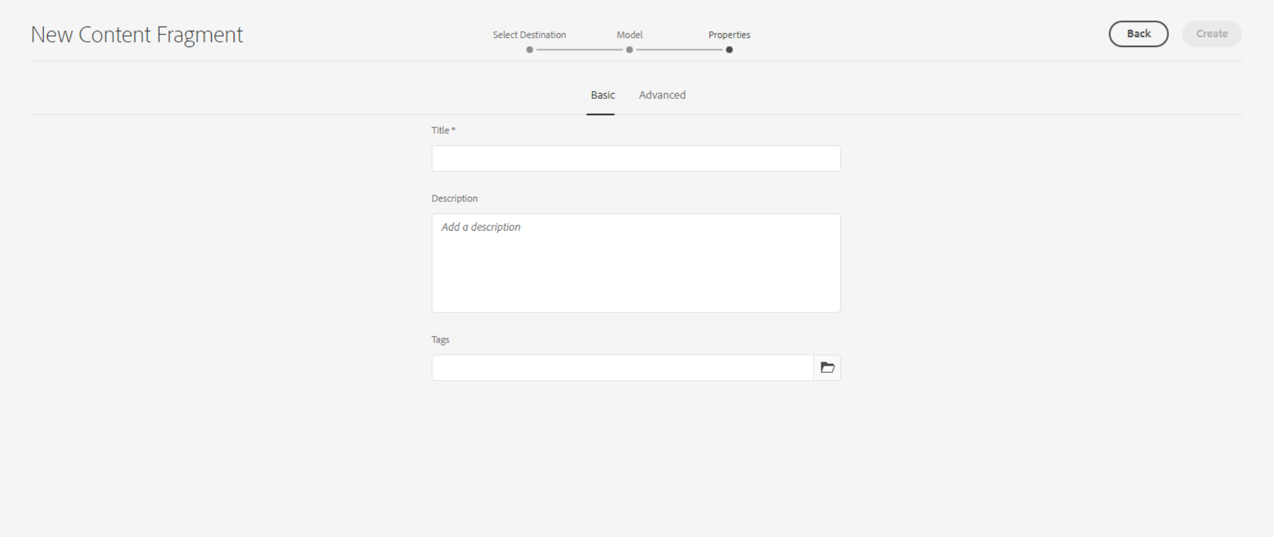

Then above window will be open, inside the Basic tab add below fields.

**Title** – This should be in 2 or 3 words as news title.  
For E.g. : **this-remembrance**

**Description** - This is for Description

**Tags** - This is for Tags.

Advanced Tab

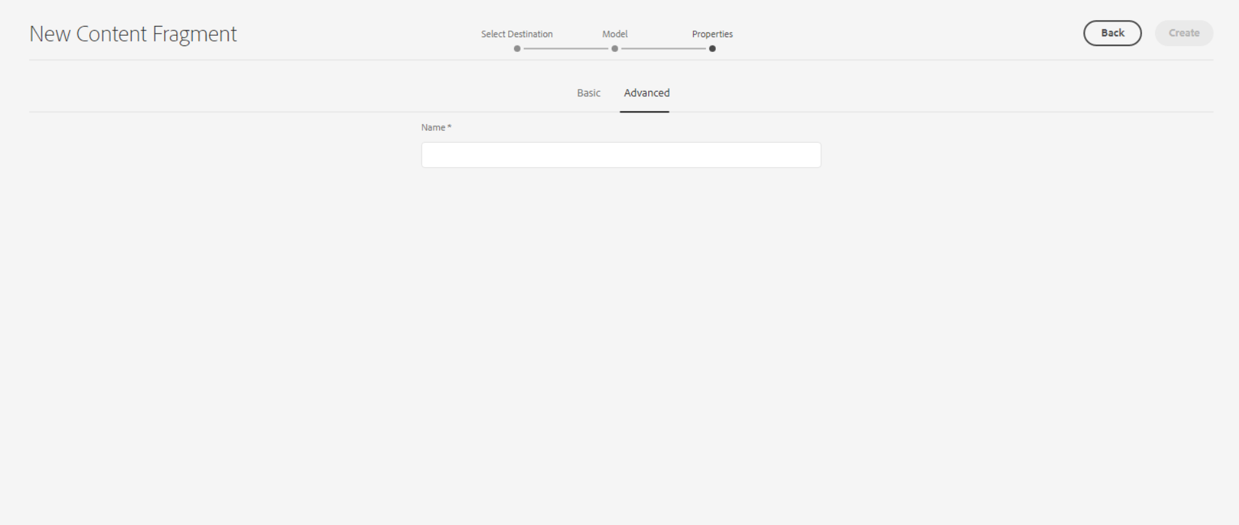

**Name** – This is for page URL. Try to add with short name.

For E.g.: **this-remembrance**

After that click on the create button, the latest content fragment will show on the first as per the below screenshot.

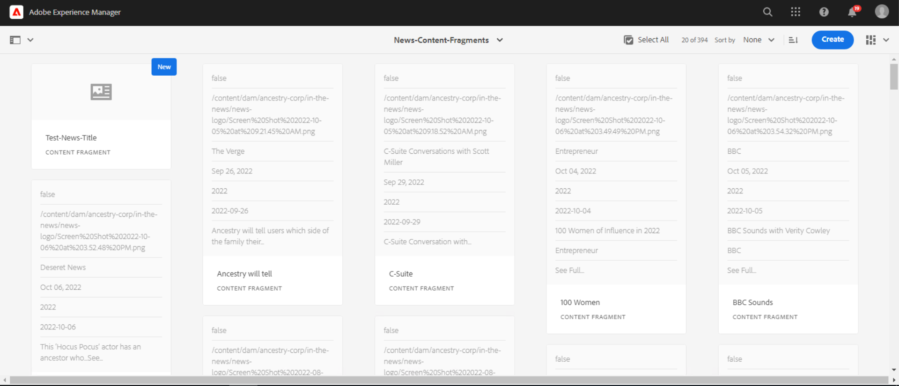

Then click on content fragment, and author it.

Below window will be open to author the news.

**Display On Homepage** - Check this box to display this News data on the homepage Featured News component.

Latest three news as per year will be visible on the homepage.

<https://www.ancestry.com/corporate/>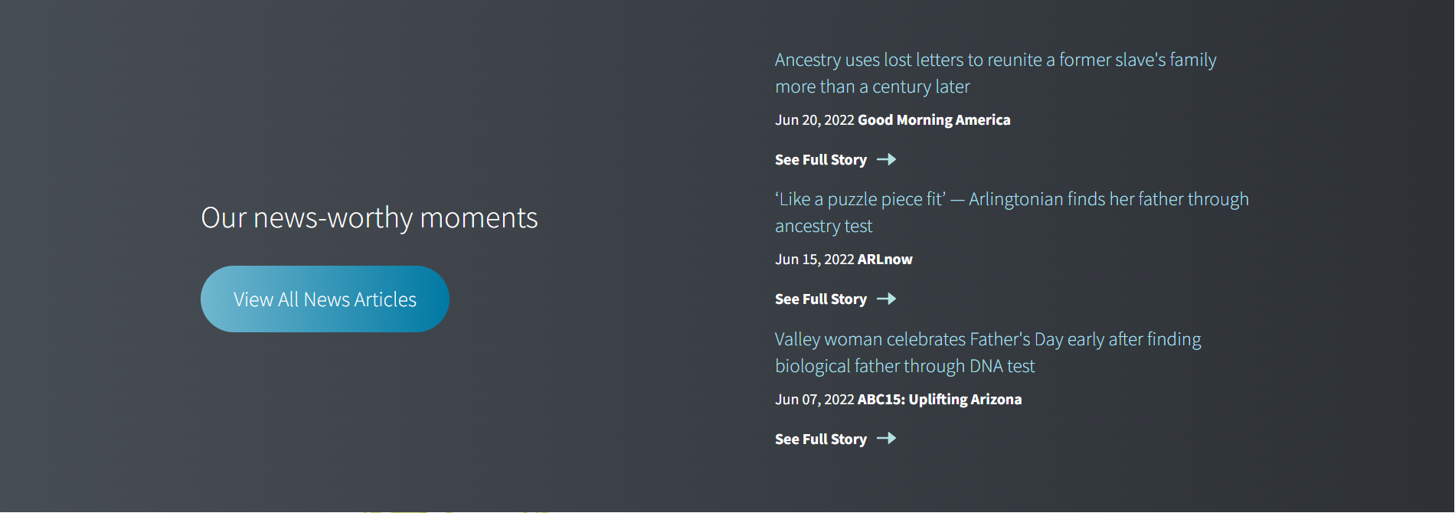

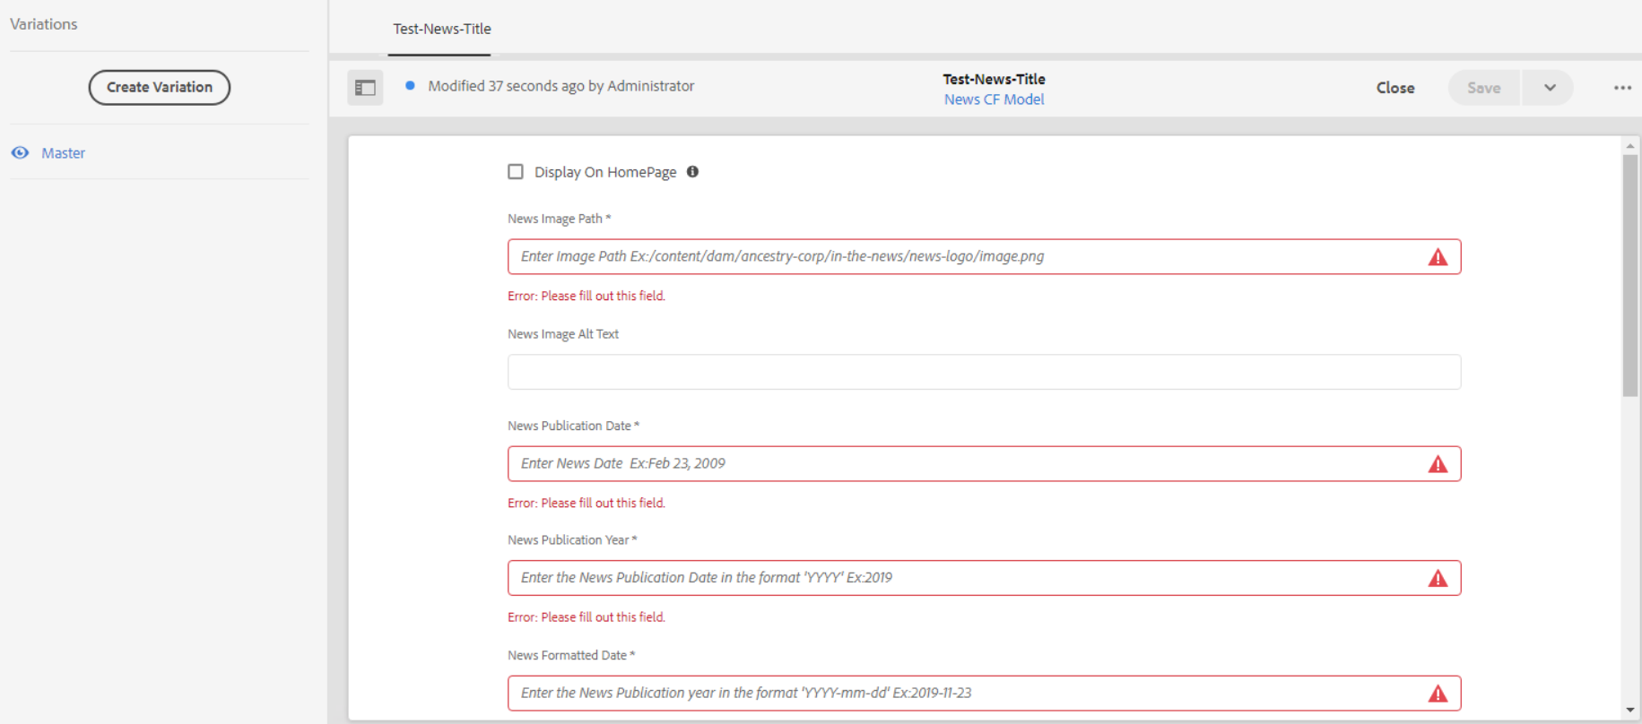

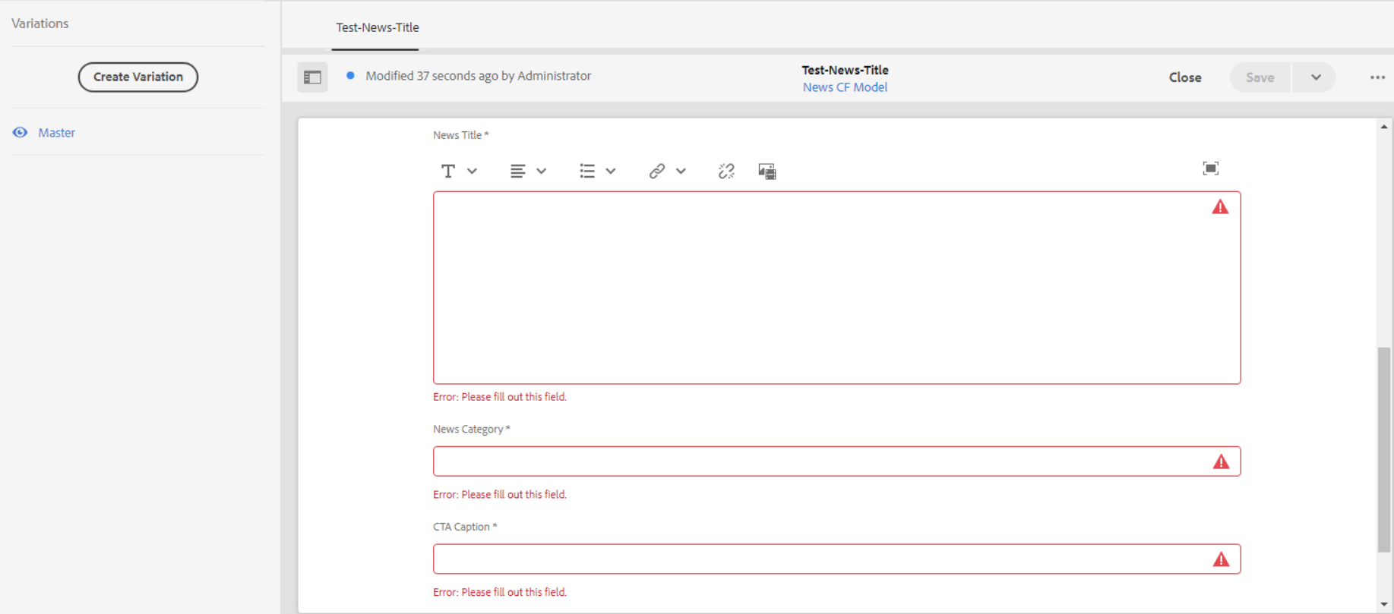

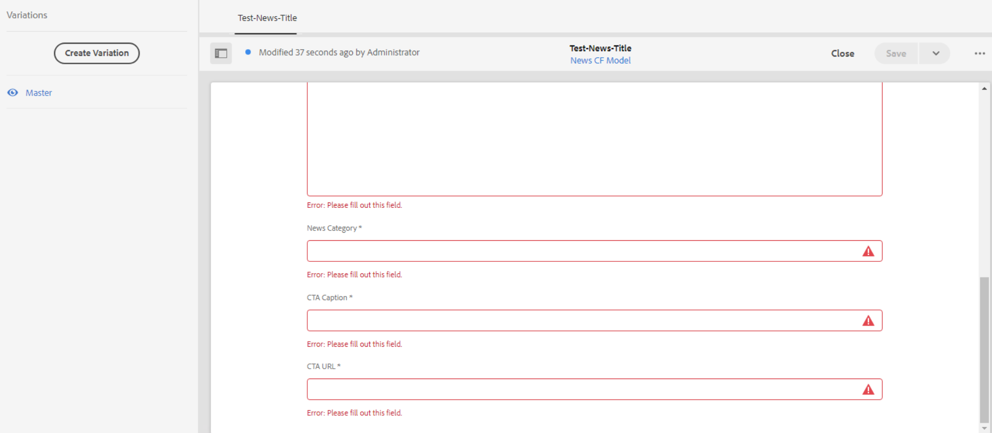

**News Image Path** – Here we can add news logo image path which is added inside the asset folder.

News Image Alt Text – This is for alt text of the news logo

News Publication Date – This is for news publication date. For E.g : [Nov 08, 2022](https://nationalpost.com/sponsored/news-sponsored/this-remembrance-period-research-your-own-familys-wartime-history)

News Publication Year - This is for news publication year. For E.g : [2022](https://nationalpost.com/sponsored/news-sponsored/this-remembrance-period-research-your-own-familys-wartime-history)

News Formatted Date - This is for news formatted date. For E.g : 2022-11-08

News Title – This is for News Title.

For E.g. : This Remembrance period, research your own family’s wartime history

News Category - This is for News category. For E.g. : National Post

CTA Option - This is for News Title. For E.g. : See Full Story

CTA URL - This is for News Title. For E.g. : CTA URL

Once all fields are filled then click on save.

Latest new will be display on news listing page

Author URL - <http://localhost:4502/content/ancestry-corp/en-us/newsroom/in-the-news.html?wcmmode=disabled>

Live URL - <https://www.ancestry.com/corporate/newsroom/in-the-news>